PRN : 25070521167 Experiment – 1

1.1.1 Area of Circle

A) Algorithm :

1. Start
2. Read radius (r) from user as a floating-point number
3. Set pi = 3.14
4. Compute area = pi * r * r
5. Print area formatted to 4 decimal places
6. Stop

B) Flowchart :
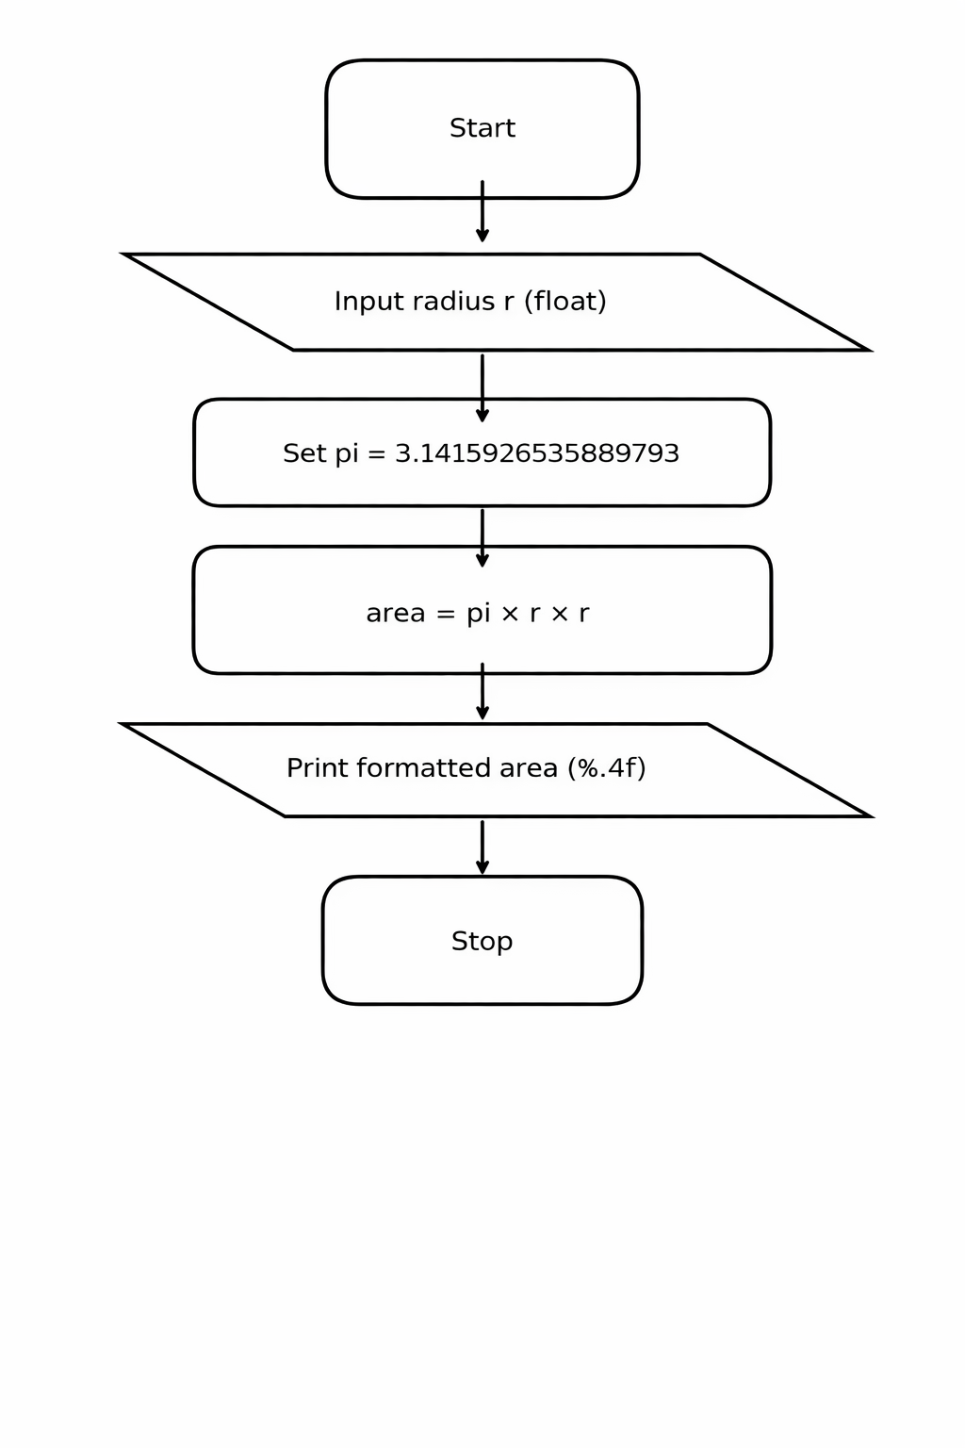

C) Python Code:
radius = float(input())
pi = 3.14
area = pi * radius * radius
print(f"{area:.4f}")

D) Execution:
